**Rotary District 5500 HOME PAGE**

**PROSPECTIVE MEMBERS**

Rotary International is a global network of community volunteers with members, known as Rotarians, who work together to create positive change in their communities and around the world.

Rotary District 5500 (D5500) is made up of more than 50 Rotary Clubs in Southern Arizona, where our members put service above self. Our 1,500 members are leading and partnering on projects that create lasting local and global community change. Our D5500 members come to Rotary to serve. They stay for the friendships and relationships they build. **Learn more about joining Rotary.**

**PROSPECTIVE MEMBERS**

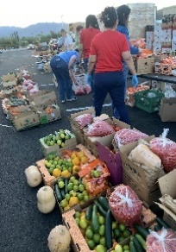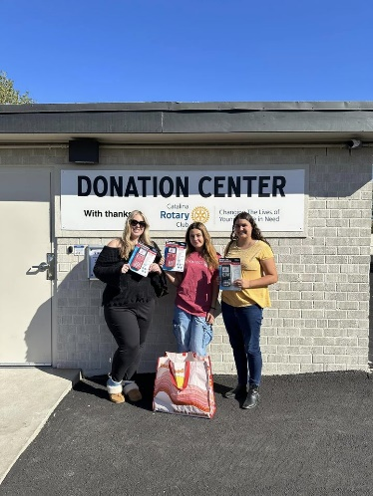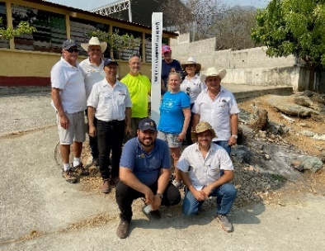

**Developing Fighting Helping the Promoting Riding to   
 Communities Hunger Homeless Peace End Polio**

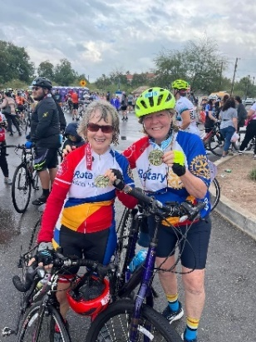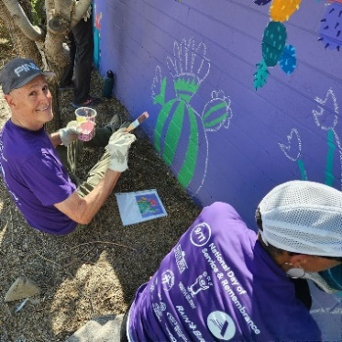

**Rotary is for everyone! You belong here!**

Rotary is for everyone of all ages and stages of life. Our impact starts with our members — people like you who see a world where people unite and take action to create lasting change across the globe, in our communities and in ourselves. At our District 5500 Rotary club meetings in communities across Southern Arizona, our people of action come together to strengthen their connections to friends and neighbors — and their commitment to improving lives.

[**Find a local Rotary club**](https://www.rotaryd5500.org/district-5500-clubs-and-info/)

**What are the benefits?**

At regular meetings and events, you’ll:

* Discuss your community’s needs and develop creative ways to meet them.
* Connect with other leaders who are changing the world.
* Expand your leadership and professional skills.
* Catch up with good friends and meet new ones locally, nationally, and globally.
* Have fun!

**](https://youtu.be/voP3rZEsVq8?si=Czs4TXQp47Tvk3Nn)SEE THE MAGIC OUR ROTARIANS MAKE IN SOUTHERN ARIZONA!**

**Learn more about becoming a member of a   
Rotary D5500 club.**

**BECOMING A ROTARY CLUB MEMBER**

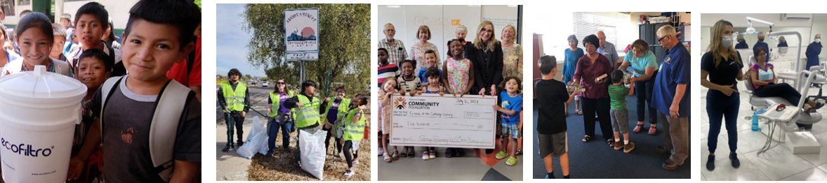

**Providing Saving the Serving Our Supporting Treating  
 Clean Water Environment Youth Education Disease**

**Who can join?**

We’re looking for people who want to give back to their communities. We welcome professional adults and retirees, young professionals, and college and high school students for membership in one of our many clubs in Southern Arizona

If you’re between the ages of 12 and 18, you may be interested in joining an [**Interact**](https://www.rotaryd5500.org/interact/) club, a service club for youth. If you are 18 years old, you may be interested in joining a [**Rotaract**](https://www.uazrotaractclub.org/) club. Make friends, develop leadership skills, and create positive change.

**How can I become a member?**

To help us find the right club for you, we’ll ask you a few questions about yourself and your interests. Then we’ll share your answers with Rotary leaders in your community, who will match you with a club and invite you to come attend a club meeting as a guest. Clubs accept new members via invitation by the club president or membership chairperson.

**What’s expected of me?**

As a club member, you will be asked to:

* Use your professional/personal skills and talents to make a difference
* Attend meetings and events
* Pay club annual dues

[**Inquire about joining a Rotary D5500 club.**](https://www.rotary.org/en/get-involved/join)

